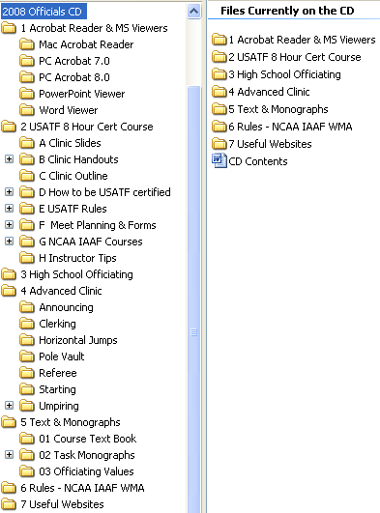
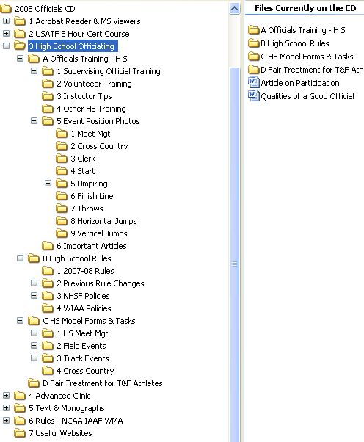

Instructions for Using the CD and Information on its Content
- Acrobat and Other Readers
  - Acrobat readers are versions 7.0 and 8.0. They are available in both Mac and PC formats. Double click on the file icon and it will install on your computer.
  - PowerPoint Viewer – install on your computer if you do not have the Microsoft Office suite installed on your computer.
  - Word Viewer – install on your computer if you do not have Microsoft Word installed on your computer.
- USA Track & Field 8-hour Officials Certification Course
  - Course slides – includes the slides presented at the clinic.
  - Handouts provided at the clinic – includes CD contents and instructions, printout of course slides, a listing of officiating opportunities for the coming year, evaluation forms, Association Level rules review, and the clinic registration form.
  - Course Outline – this is a detailed outline of the information presented during the clinic
  - How to become a USATF Certified Official includes the Pacific Northwest Association’s meet practicum form, and the USATF certification requirements for association, national, and master level officials; the rules reviews to be completed to complete the certification process; and the USATF Certification database form to be submitted to the Association’s Certification Chair, William Hickman.
  - USATF Rules – how to download the current rules from the USATF.ORG/Officials/ website
  - Meet Planning and Forms
    - Planning checklists
    - Model forms
    - Entries and lanes
    - Officials, field
    - Event officiating task descriptions
    - Field event forms
    - Track event officiating task descriptions
    - Track event model forms
    - Crews (block and hurdle crews)
    - Race walk officiating
    - Cross country and long distance running forms
    - Announcing tasks
    - Meet scoring
    - Protests
    - Metric conversion tables
    - Templates and diagrams
  - Collegiate and International Courses
  - Instruction tips for presenting this or the short course clinics
- High School Officiating Need to Knows
  - High School Training Program – Supervising Official and Volunteer official training, volunteer event-by-event task descriptions, evaluation, high school rules, other training, and instruction tips
  - Best officiating practices forms and tasks – meet management, field events, track events and cross country
  - High School Event Positioning Photos – photos and slide shows illustrating best practices officials positioning clerk, start, umpiring, finish line, throws, horizontal jumps, vertical jumps, and cross country
  - WSTFCA Proposal: Fair Treatment for High School Track & Field Athletes – this proposal identifies the need for high school track and field athletes to receive the same resources to support officiating as all other high school sports receive
  - NFHS Rules and Policies – information on current rules and policies that apply to high school competitions and best practices articles
  - WIAA Policies – policies established by the Washington State High School Federation to augment the National Federation’s rule book and state best practices
- Advanced Clinic – clinic content and handouts from the annual PNTFOA Advanced Clinic for certified officials – continuing education and updating topics include:
  - Announcing
  - Clerking
  - Horizontal jumps
  - Pole vault
  - Referee
  - Starting
  - Umpiring
  - Vertical jumps
- Course Text and Officiating Task Monographs – course text book along with monograph chapters written by the nation’s best officials covering model officiating practices for:
  - Clerk
  - Combined events
  - Cross country,
  - Events management and administration
  - Field events
  - FieldLynx
  - Lap scoring
  - Long distance running
  - Marshals
  - Mentoring new officials
  - Race walking
  - Starting
  - Technical manager
  - Throws
  - Umpiring
  - Vertical jumps
  - Weights and measures
- Rules – NCAA IAAF World Masters Association– Downloads and information
- Useful Websites – listing of websites with substantive content and information for the working official

